First Machine Learning Project
Breast cancer dataset from Kaggle
Documentation:
https://scikit-learn.org/stable/modules/generated/sklearn.model_selection.train_test_split.html

Algorithm used:
https://scikit-learn.org/stable/modules/generated/sklearn.ensemble.GradientBoostingClassifier.html

Target with only 2 types: binary
In our case it is the status column: alive vs dead

Splitting and then encoding the dataset
Encoding: assigns a number to each categorical variable (alive 1, dead 0)

Why do we split the data?
To train the data, can do all the preprocessing to improve the model in the training,
Use validation set to check if our model is good, can it generalize real world data?

We need to minimize overfitting.

The model:
Use gradientboosting
Use gridsearch to select which are better

Cross Validation
Confusion Matrix – type

Normalization vs Standardization? Which is best for our data

For another day:
Feature selection: many might be irrelevant
Minimum redundance- selecting the features with the least redundancy, and those with the most relevance

https://www.analyticsvidhya.com/blog/2020/09/precision-recall-machine-learning/

What I tried:
Libraries used
import pandas as pd
import numpy as np
from sklearn.model_selection import train_test_split
from ydata_profiling import ProfileReport
from sklearn.preprocessing import LabelEncoder
from xgboost import XGBClassifier
import xgboost as xgb
from sklearn.ensemble import GradientBoostingClassifier
from sklearn.ensemble import HistGradientBoostingClassifier
from sklearn.model_selection import cross_val_score, GridSearchCV, KFold, RandomizedSearchCV, train_test_split
from sklearn.metrics import auc, accuracy_score, confusion_matrix, mean_squared_error
from sklearn.model_selection import GridSearchCV

XGboost binary classifier, using X_test and Y_test

xgb_model = xgb.XGBClassifier(objective="binary:logistic", random_state=42)
xgb_model.fit(X_test, Y_test)

y_pred = xgb_model.predict(X_test)

print(confusion_matrix(Y_test, y_pred))

output: [[685 0]
[ 0 120]]

Now trying gridsearch to choose hyperparameters (hyperparameter?)
For improving model
Good for when hyperparameter values are small
Bayesian optimization: models the underlying function that maps hyperparameters to the model performance
Requires more computational resources, but is better for large # of hyperparameters and large search space

To implement: must define your hyperparameters, examples include learning rate, model architectures, number of estimators

MRMR: Maximum Relevance — Minimum Redundancy
Number of features you want to keep: K
Works iteratively: identifies the best feature, and adds it to a bucket of selected features, never leaves
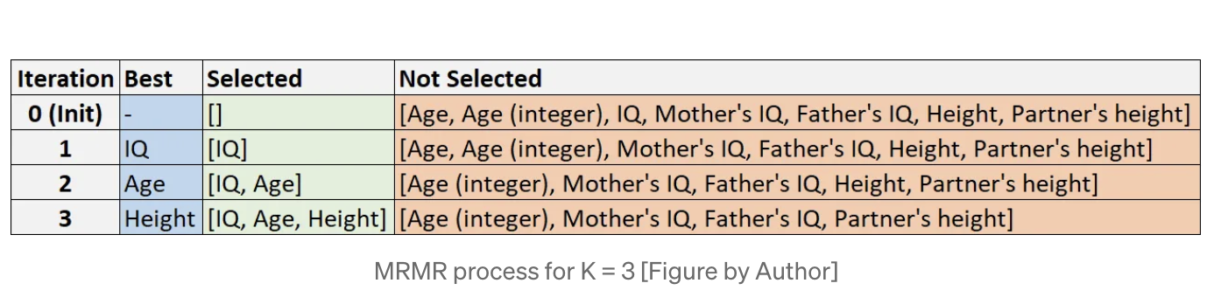
https://towardsdatascience.com/mrmr-explained-exactly-how-you-wished-someone-explained-to-you-9cf4ed27458b

uses F statistic to compute the score for each feature

pip install mrmr_selection

from mrmr import mrmr_classif
from sklearn.datasets import make_classification
# create some data
X, y = make_classification(n_samples = 1000, n_features = 50, n_informative = 10, n_redundant = 40)
X = pd.DataFrame(X)
y = pd.Series(y)
# use mrmr classification
selected_features = mrmr_classif(X, y, K = 10)

